Mahad Abubakar L1F26BSCS0314
Task 07– Weather App (Draw the Flowchart, then Code) Estimated time: 15 minutes A weather app shows the temperature in Celsius, but tourists want to see it in Fahrenheit as well. The formula is: Fahrenheit = Celsius * 9 / 5 + 32
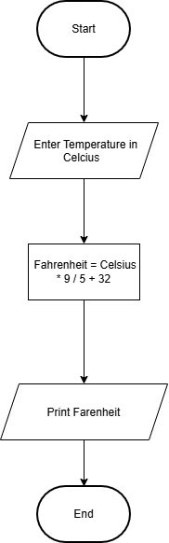

Task 8– Cinema Ticket (Reading a Flowchart with a Decision) Estimated time: 15 minutes A cinema gives a half ticket to children below 12 years and a full ticket to everyone else. The counter staff use a flowchart to decide which ticket to print. There is no coding in this task: you only read and draw flowchart
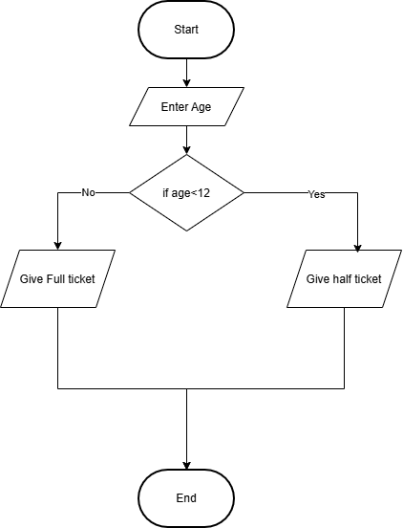
No | Age | Condition (age<12) | Ticket printed
1 | 8 | true | half
2 | 12 | false | full
3 | 30 | false | full

Task 03– Expression Quiz (Precedence and Associativity) Estimated time: 15 minutes Your teacher gives a quiz in which you must evaluate expressions without a calculator. Check your answers using the compiler. Requirements 1. BEFORErunning anything, fill the Your Prediction column of the table on paper. 2. Print every expression using one cout statement, for example: cout << "Expression 1: " << 10 + 5 * 2<
no | expression | Prediction | Output
1 | 10 + 5*2 | 20 | 20
2 | (10 + 5) * 2 | 30 | 30
3 | 20- 5- 3 | 12 | 12
4 | 100 / 7 | 14 | 14
5 | 100 % 7 | 2 | 2
6 | 2 * 3+8/4-1 | 9 | 8

https://github.com/mahad314/Lab-3

